NO PAPAYA

PAPAYA1

1

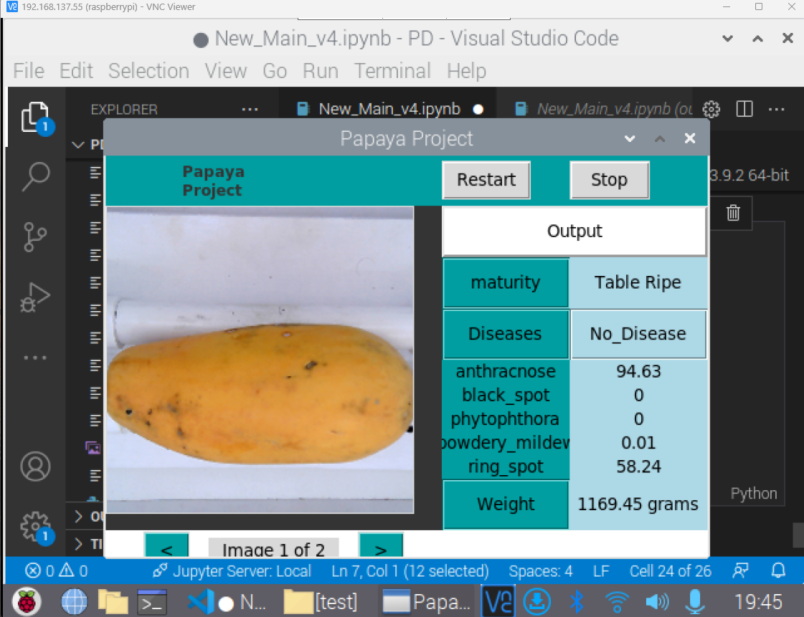

2

3

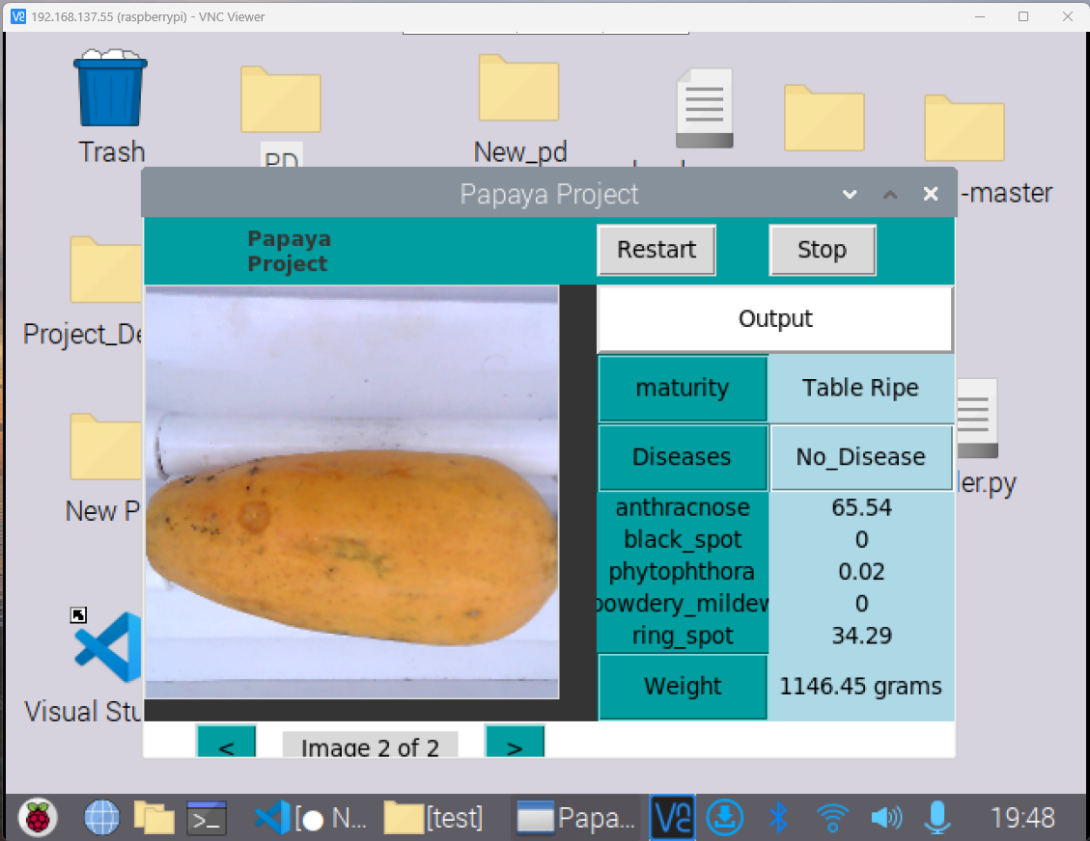

4

5

6

7

8

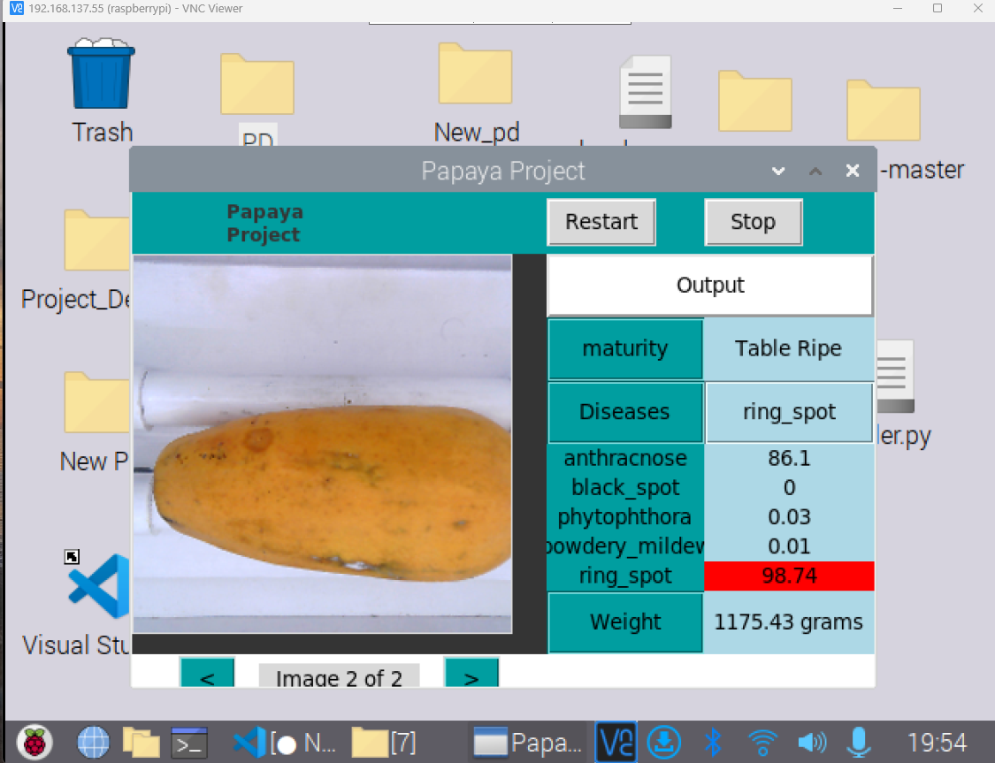

9

10

